
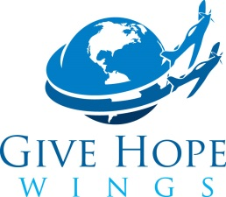

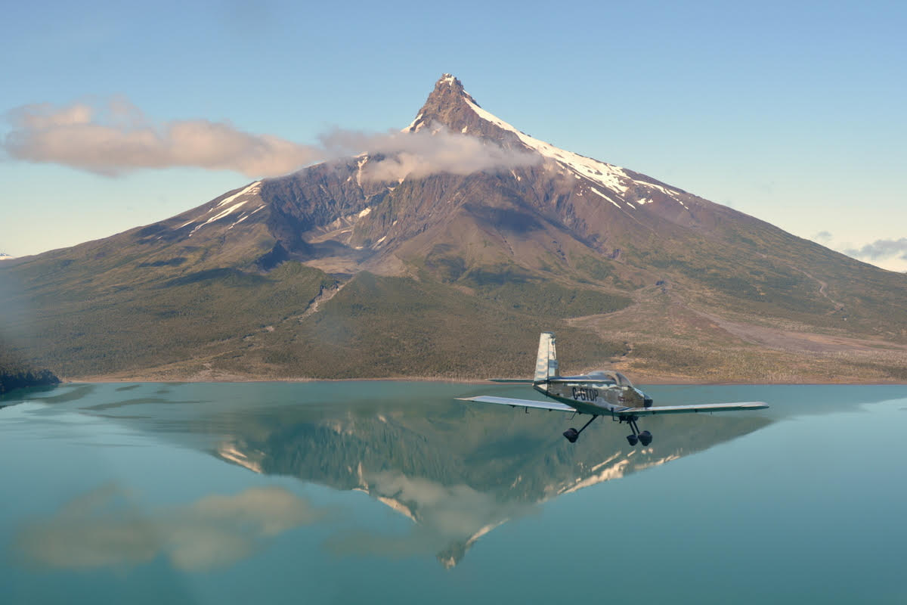
How did three men turn a dream into reality and raise more than $500,000 for Hope Air?
The Give Hope Wings Story
One epic flight which has launched thousands of others

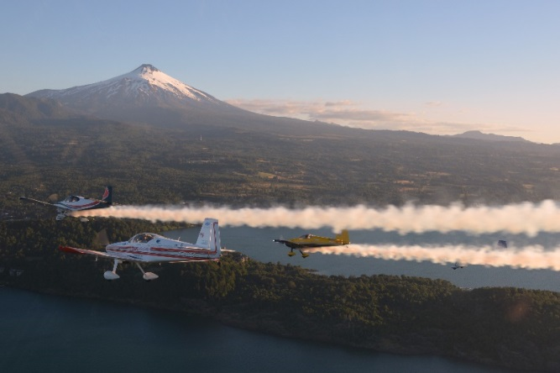
Harold Fast will give a power point presentation of their January / February trip circumnavigating Central and South America
Flying with the Chilean RV Aerobatic group in the Villarrica Chile

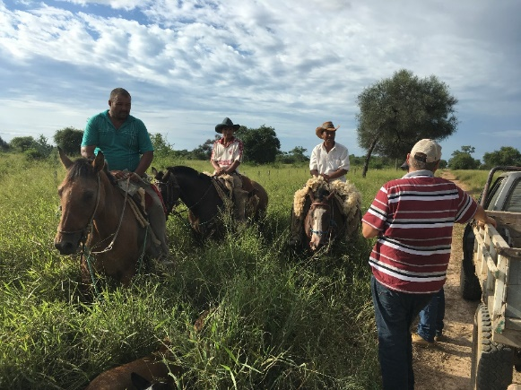
Because the GHW volunteer Pilot program was oversold
for the Santiago – Ushuaia – Buenos Aires leg, Harold
gave up his seat and visited farmer friends in the
Chaco Paraguay

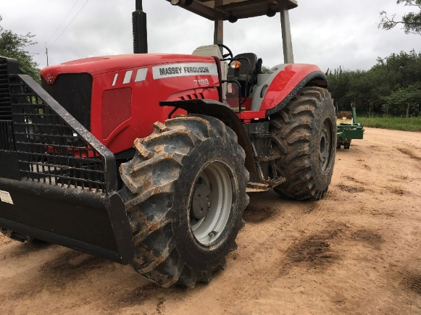

Note the double tires on the Massy, purpose is to reduce punctures from thorns. This is why it will be a long time before motor bikes will replace the horse for working with the cattle

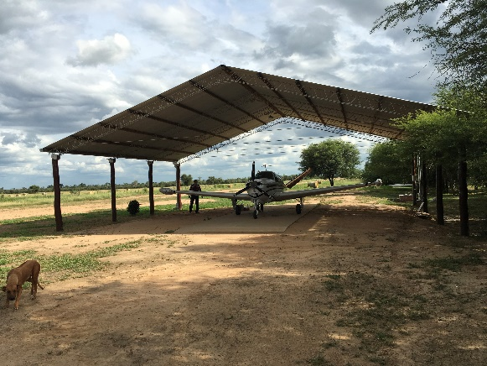

After flying from Filedelfia we park in Erland’s ranch
Hanger.

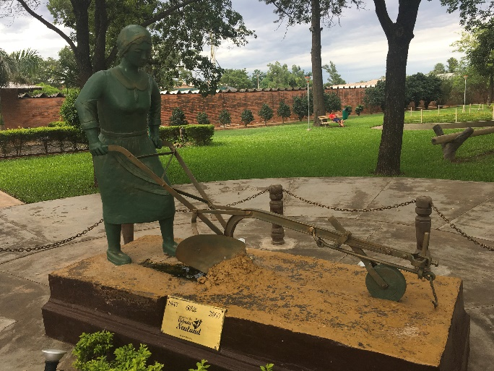

Neuland Colonia was settled in 1947 mostly by Russian and Ukrainian widows of WW2 and Stalin’s purges

